Name: Rajdeep Sarkar
Roll: UG/02/BTCSECSF/2023/008
UDB ALB ASSIGNMENT 5
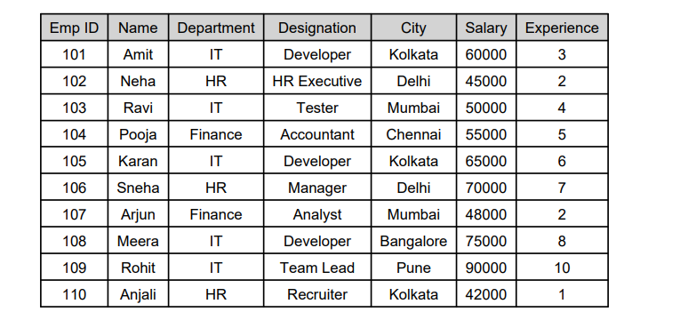
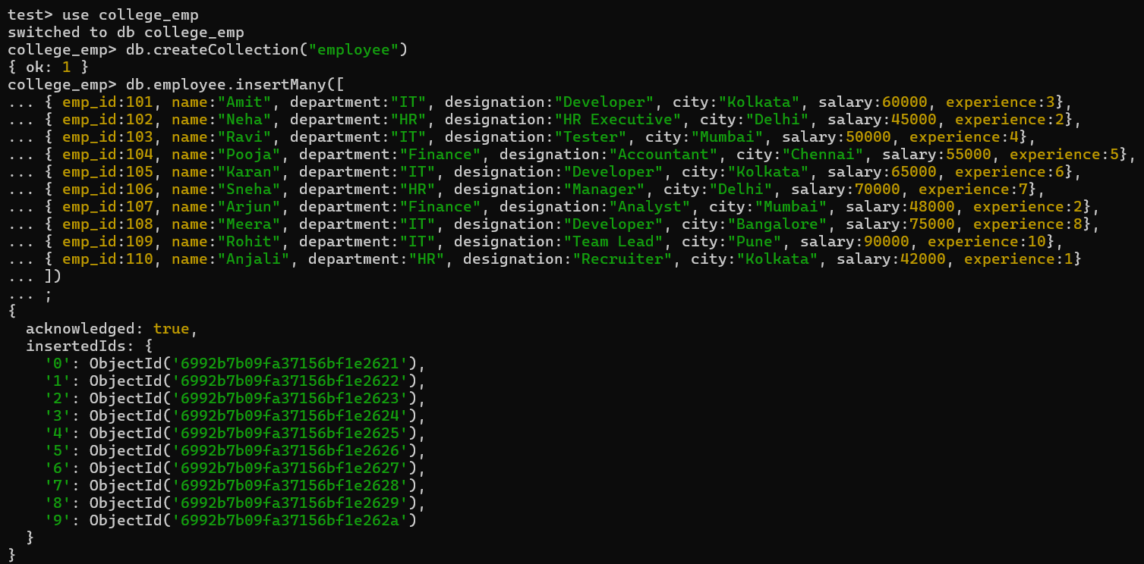

Q1. Display all employee records.
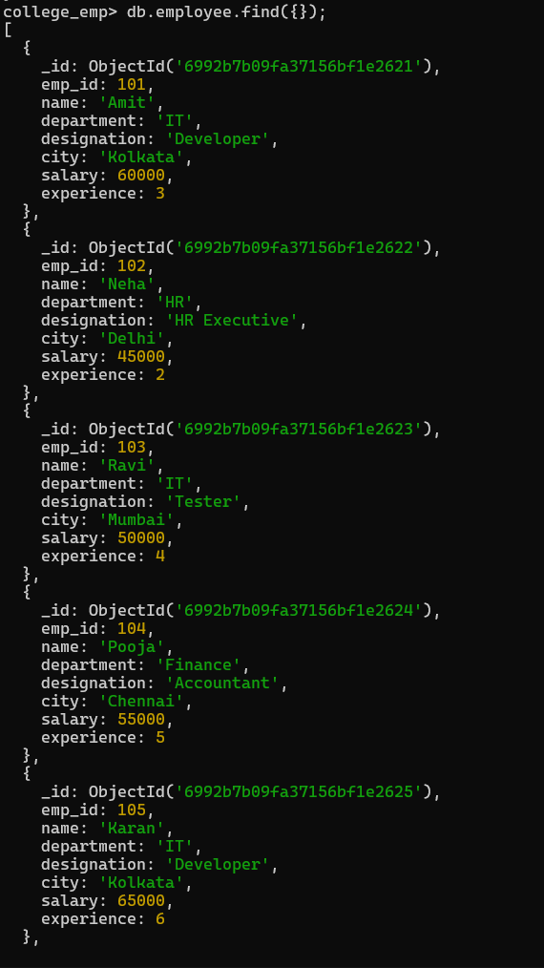
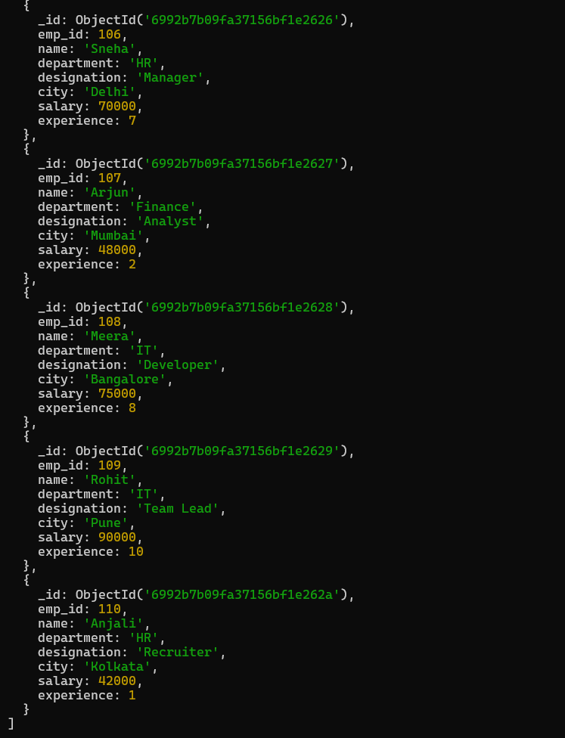
Q2. Create an index on emp_id field.
Q3. Create an index on department field.
Q4. Create a compound index on department and salary.

Q5. Find employees working in IT department.
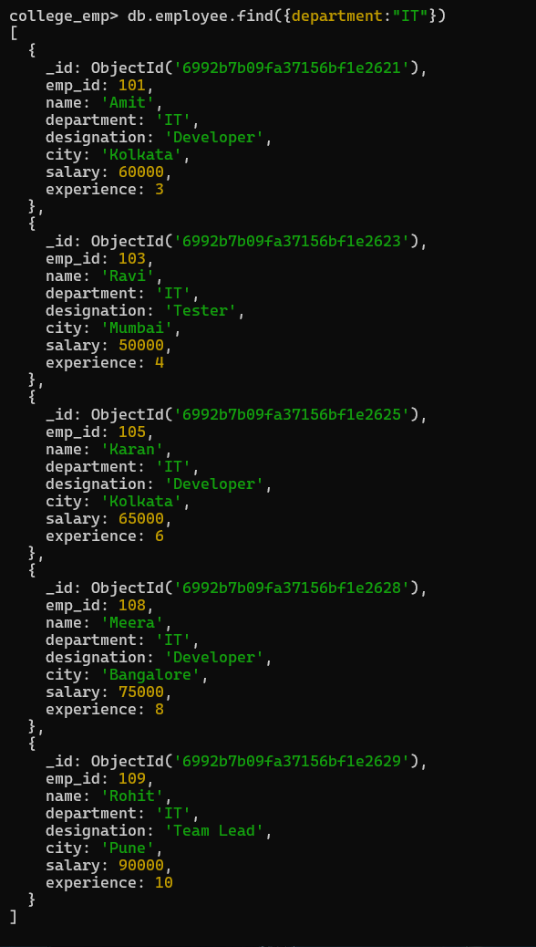
Q6. Display employees whose salary is greater than 60,000.
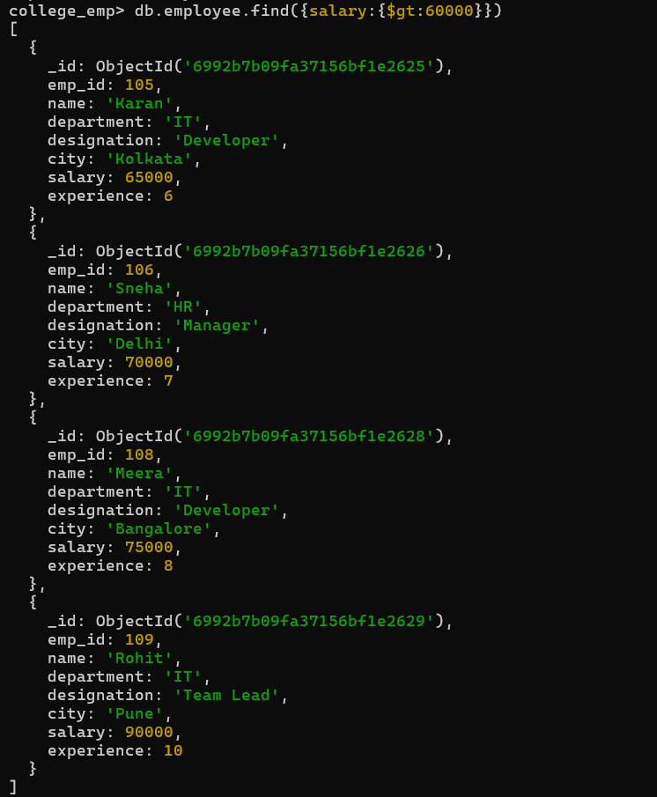
Q7. Sort employees by salary in descending order.
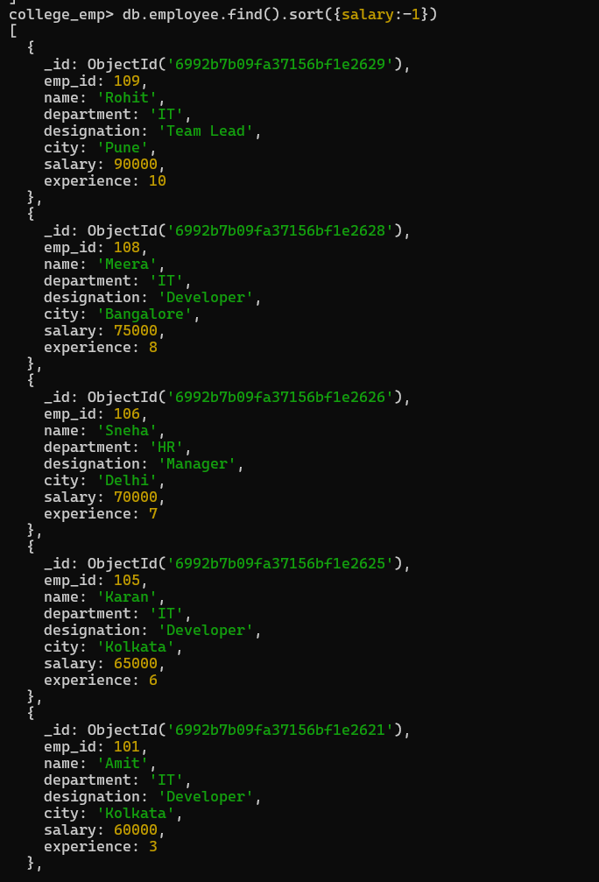
Q8. Display top 3 highest paid employees.
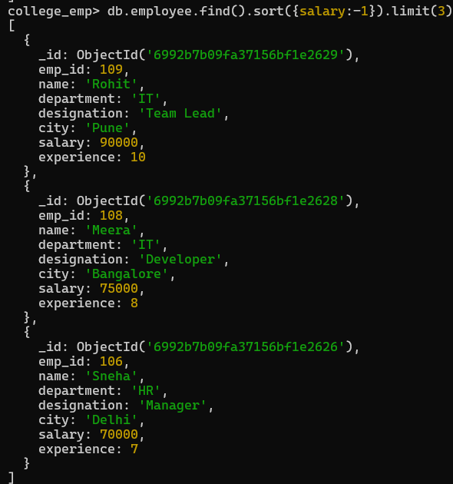
Q9. Display employees having experience more than 5 years.
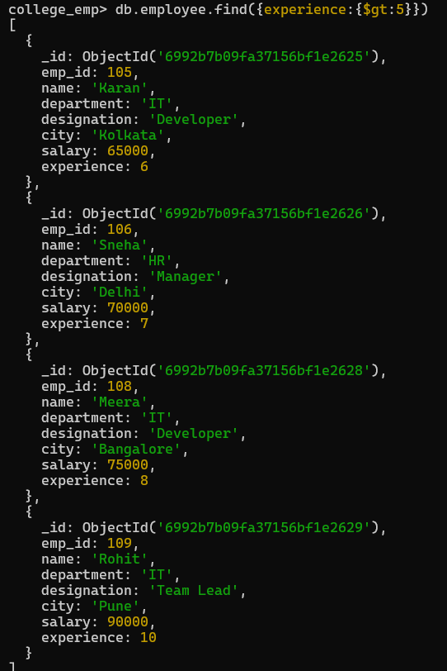
Q10. Analyze query performance using explain().
